Phase 2: Org Setup & Configuration

PROJECT : Consumer goods distributor partner portal

1. Introduction
Phase 2 focuses on setting up the Salesforce environment and configuring the org to meet project requirements. Proper org setup ensures security, proper access, and a solid foundation for further development and automation.
Objectives:
- Set up Salesforce Developer Org and Sandboxes.
- Configure company profile, fiscal year, business hours, and holidays.
- Set up users, roles, profiles, permission sets, and access policies.
- Understand deployment basics using Salesforce CLI and VS Code.

2. Salesforce Edition & Company Profile

2.1 Salesforce Edition
- Chose Developer Edition for learning and project development.
- Enabled Lightning Experience for modern UI.
Screenshot Suggestion: Salesforce Setup → Company Settings → Company Information.
Take screenshot: The page showing Organization Name, Salesforce Edition, Instance.

2.2 Company Settings
- Company Profile: Added company details like name, address, primary contact, currency, default locale.
- Business Hours & Holidays: Defined standard business hours and holidays for workflow and approval processes.
- Fiscal Year Settings: Configured standard fiscal year to align with reporting requirements.
- 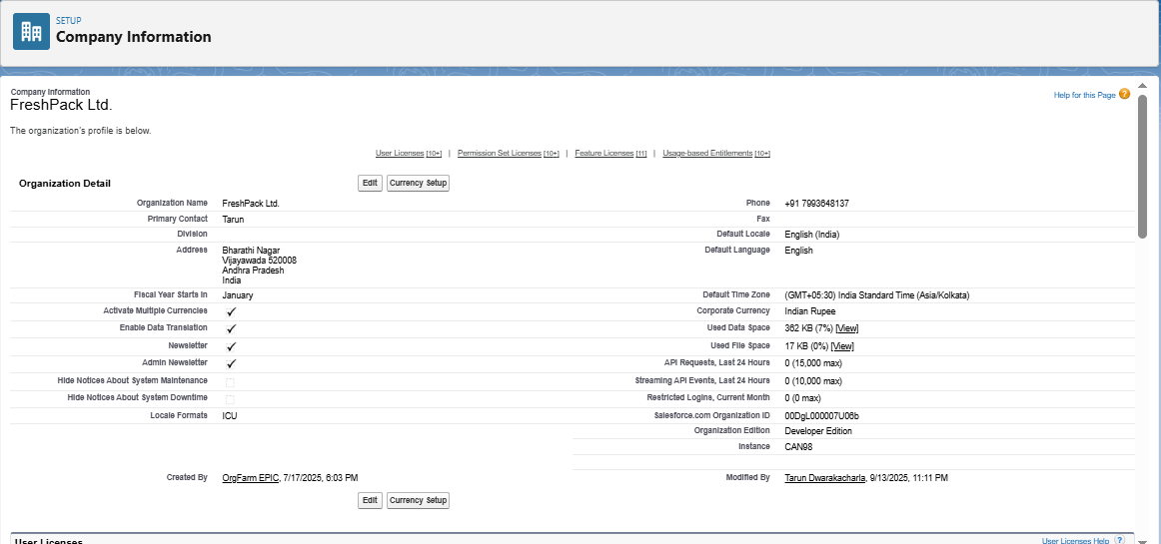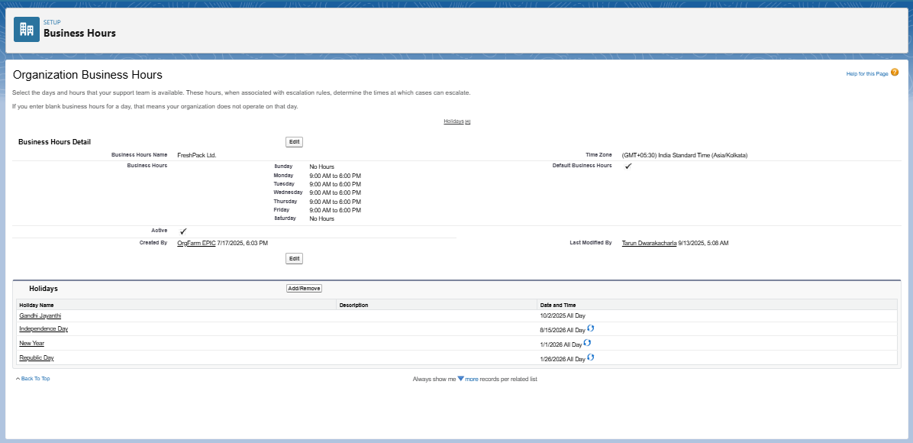

3. User Setup & Access Management

3.1 Users & Licenses
- Created test users for Admin, Distributor, and Partner roles.
- Assigned appropriate Salesforce licenses and feature licenses.

3.2 Profiles
- Defined profiles to control access:
  - Admin Profile: Full CRUD permissions on all objects.
  - Distributor Profile: Limited access to Partner Order, Product, and Inventory objects.
- Configured tab visibility and object permissions.
.

3.3 Roles
- Created roles to define the hierarchy:
  - Admin → Distributor → Partner Manager.
- Roles control record-level access in combination with sharing rules.

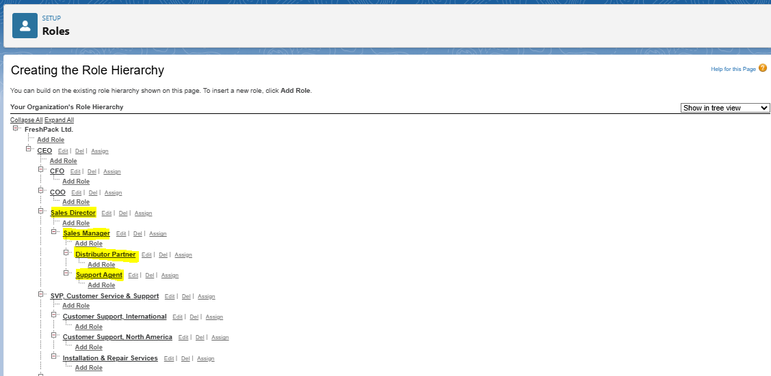3.4 Permission Sets
- Created permission sets for additional access beyond profiles, e.g., API access, custom object access.
- Assigned permission sets to users as required.

4. Organization-Wide Defaults & Sharing Rules
- Configured OWD (Organization-Wide Defaults) to ensure proper record-level security:
  - Partner_Order__c: Private
  - Inventory__c: Public Read Only
- Created Sharing Rules to share Partner Orders with Admins and Managers automatically.
Setup → Security → Sharing Settings → OWD Table.

5. Login & Security Policies
- Configured Login Access Policies to allow admins to log in as users for support and troubleshooting.
- Configured Login IP Ranges and Session Settings for security compliance.
Setup → Security → Login Access Policies.

6. Developer Org Setup & Sandbox Usage

6.1 Dev Org Setup
- Created a Developer Org for the project.
- Connected VS Code with Salesforce CLI (SFDX).
VS Code Setup Steps:
- Installed Salesforce CLI.
- Installed Salesforce Extension Pack in VS Code.
- Authorized the org:
- sf login org --alias DevOrg
- Created project folder structure:
- sfdx force:project:create -n ConsumerGoodsPartner
VS Code → Salesforce CLI Terminal showing successful login.

6.2 Sandbox Usage
- Created Partial Copy Sandbox for testing deployment without affecting production data.
- Configured sandbox refresh schedule.
Setup → Sandboxes → Sandbox List.

7. Deployment Basics
- Learned metadata deployment using Salesforce CLI:
  - Deploy Apex classes, objects, and flows from VS Code:
  - sf deploy metadata --metadata ApexClass --target-org DevOrg --wait 10
- Checked deployment status and logs to ensure successful code migration.
Screenshot Suggestion: VS Code terminal showing deployment success.

8. Outcome of Phase 2
- Salesforce org fully configured with company profile, fiscal year, business hours, and holidays.
- Users, profiles, roles, and permission sets configured for project security and access control.
- Developer org connected to VS Code for easy code and metadata deployment.
- OWD and sharing rules established for record-level security.

